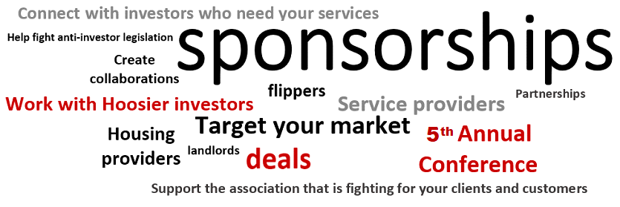

Sponsorship agreement– please complete and email to AKOIN1@MSN.COM. Upon receipt, we will send you an invoice to pay online.

Date ________________________________________

Company Name:

Company Tag or Advertising line:

Company Phone Number:

Address_________________________________________________________________

City: State: Zip:

Company web site:

Contact Person and Title:

Phone: E-mail:

List 3 products/services you provide to real estate investors that you will be selling to our members:

- _____________________________________________________________________

- _____________________________________________________________________

- _____________________________________________________________________________
________PLATINUM LEVEL SPONSORSHIP $7,500.00/Year
Your logo and contact information placed on our website for one year, in newsletters and reaching over 1,600 investors each month.
You will have a TABLETOP DISPLAY at the ANNUAL CONFERENCE IN APRIL with over 250 attendees*. Includes membership for up to four people. Private Investors round table and reception (4 VIP Reception/Dinner Tickets), photo opportunity, & Event Sponsorship Signage.
AND AN HOUR SPEAKING SPOTLIGHT time at the ANNUAL CONFERENCE During working lunch.

________GOLD LEVEL SPONSORSHIP $5,000/YEAR
Your logo and contact information placed on our website for a year, in newsletters and reaching over 1,600 investors each month.
You will have a TABLETOP DISPLAY at the ANNUAL CONFERENCE IN APRIL with over 250 attendees*. Includes membership for up to four people. Private Investors round table and reception ( 2 VIP Reception/ Dinner Tickets), photo opportunity, & Event Sponsorship Signage. TEN MINUTE SPONSOR SPOTLIGHT time at ANNUAL CONFERENCE.

________ROOFTOP LEVEL SPONSORSHIP $1595/YEAR
Your logo and contact information placed on our website for one year, in newsletters and reaching over 1,600 investors.
You will have a TABLETOP DISPLAY at the ANNUAL CONFERENCE IN APRIL with over 250 attendees*. 2 VIP Reception/ Dinner Tickets. Includes membership for up to four people.

________ANNUAL SPONSORSHIP $995/YEAR
Your logo and contact information placed on our website for one year, in newsletters and reaching over 1,600 investors. Includes membership for up to four people.

PLEASE FILL IN WHO WILL BE ATTENDING THE APRIL EVENT FOR YOUR COMPANY:

ATTENDEE #1 Title _______________Email___________________Phone___________

ATTENDEE #2 Title Email____________________ Phone

ATTENDEE #3 Title ______________Email____________________ Phone

ATTENDEE #4 Title Email____________________ Phone

PLEASE FILL IN WHAT DOOR PRIZE YOU WILL BE DONATING: _________________________________________________

Agreement signed by:

Name _______________________
Title __________ Date __________
Signature _______________________

INstateREIA sales rep: _________________________________________________

Indiana State Real Estate Investors Association
6767 E Washington St., Indianapolis, IN 46219
219-746-6217, AKOIN1@MSN.COM

